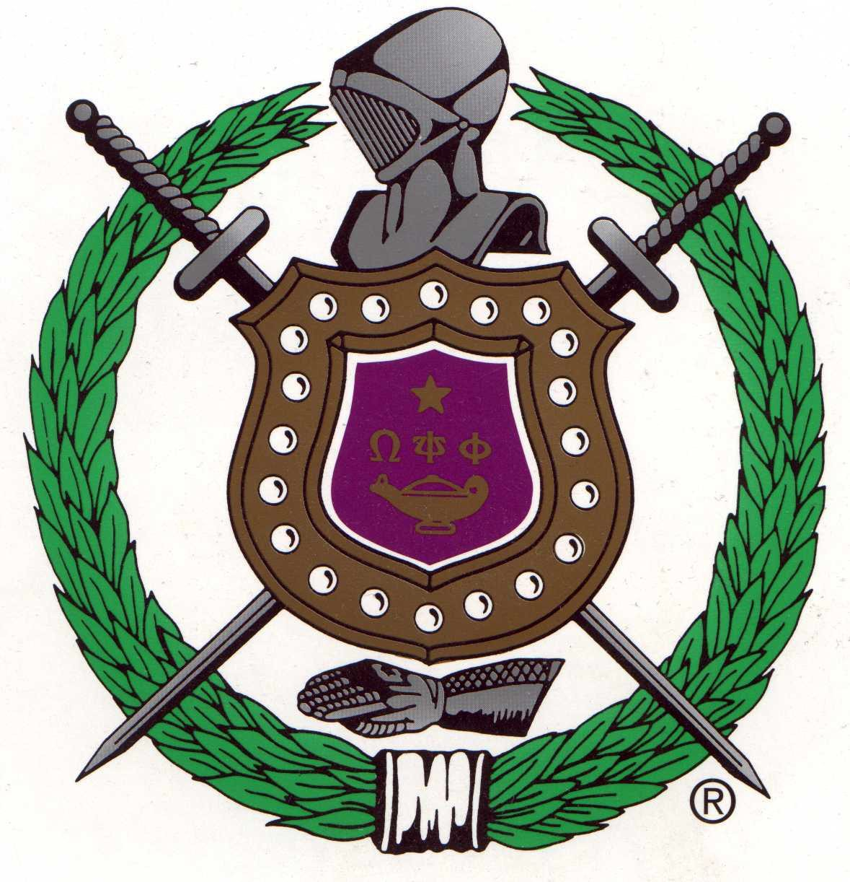

Omega Psi Phi Fraternity, Inc.
is pleased to announce its annual

International High School Essay Contest
As a mandated element of the Annual International Achievement Week Observance

Four College Scholarship Awards:
1st Place $2000.00 Scholarship 2nd Place $1500.00 Scholarship 3rd Place $1000.00 Scholarship
Contest Closes: October 14, 2022
2022 Essay Title:

A world crisis has caused a paradigm shift for health disparities and social justice; what are your suggestions for positive change?

Eligibility & Rules

Submission Process
The Contest is open to all college-bound, high school seniors who submit an essay application through a Chapter of the Fraternity.

The essay must be original and neither previously published nor secured by copyright. The essay must be between 700 and 750 words in length. The type-written, double-s paced essay may be submitted via postal service or email in Microsoft Word.

All submissions will be reviewed by your local Chapter (determined by your high school/home address). Submissions will not be accepted after October 14, 2022. Do not change or shorten the Essay Topic.

The following information for the contestant must appear on the first page in this manner:

Title: An Essay By: Home Street Address: City, State, Zip Code: Name of High School: Address of High School: Student Email: Phone # Contest Name: Omega Psi Phi Fraternity International High School Essay Contest

Name of Sponsoring Chapter: Location of Chapter:
The manuscript must be postmarked, or time stamped on the email not later than midnight,
October 14, 2022, email wlewis@shoresidelogistics.com & Thetaphikrs@opps.org
Essays are not to be sent to the Fraternity’s Headquarters facility and any

received there will be considered ineligible.

Rating Criteria

Additional Information

Local Chapter Contact
All local Chapters will assemble a review panel to assess submitted essays based on the following criteria. Essays may earn a maximum rating of 100 points.

- Development of Topic/ Thesis: (30 possible points)
Topic is well-developed (covers and develops major points, supplying enough information for understanding)

- Progression: (20 possible points)
Composition progresses from beginning to end in a logical flow of information

- Readability: (25 possible points)
Concise prose that sticks to the point and does not ramble (holds reader’s attention)

- Grammar: (15 possible points)
Agreement of subject and verb; proper tense; correct sentence construction; paragraphing, including transitional phrases linking same

- Spelling: (5 possible points)

- Punctuation: (5 possible points)

Persons submitting manuscripts thereby grant to the Omega Psi Phi Fraternity, Inc. the right to keep the manuscripts and to exercise full publishing rights to them. Awards will be announced on or about June 1, 2023, and the decision of the judges will be final. The manuscripts must present an adequate treatment of the essay topic. Winners may be required to furnish written proof that they were enrolled in their respective high school at the time the essay was submitted. Awards will be submitted to each winner, upon written verification from an institution of higher education that the individual has enrolled. Actual enrollment (not just acceptance) is required. Awards must be claimed within 18 months after the announcement date to be valid.

Local Chapter Name: Theta Phi
Bro. Will Lewis
Email: wlewis@shoresidelogistics.com

